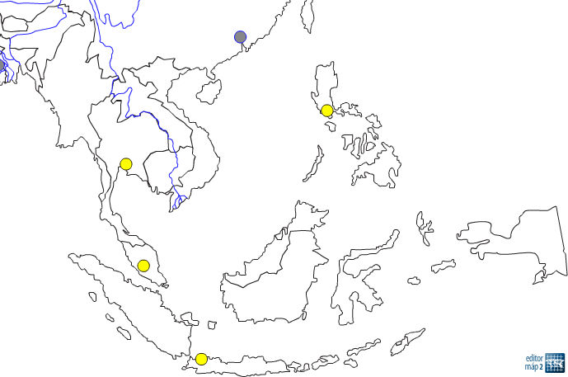

7

10

9

8

6

6

5

4

3

2

1

Zakresli do mapy:

|  |  |  |  |  |
| --- | --- | --- | --- | --- |
| Indický oceán | Juhočínske more | Polostrov Zadná India | Jáva | Filipíny |
| Andamanské more | Filipínske more | Malajský polostrov | Kalimantman /Borneo/ | Sundy |
| Bengálsky záliv | Tichý oceán | Sumatra | Sulawesi /Celebes/ | **pomenuj hlavné mestá /4/** |

Doplň štáty:

|  |  |  |  |  |
| --- | --- | --- | --- | --- |
| 1, | 2, | 3, | 4, | 5, |
| 6, | 7, | 8, | 9, | 10, |

***28 -25 = 1; 24 – 21 = 2; 20 – 14; 13 – 8; 7 – 0 = 5***